
29 Days of Prayer
For The Next Step
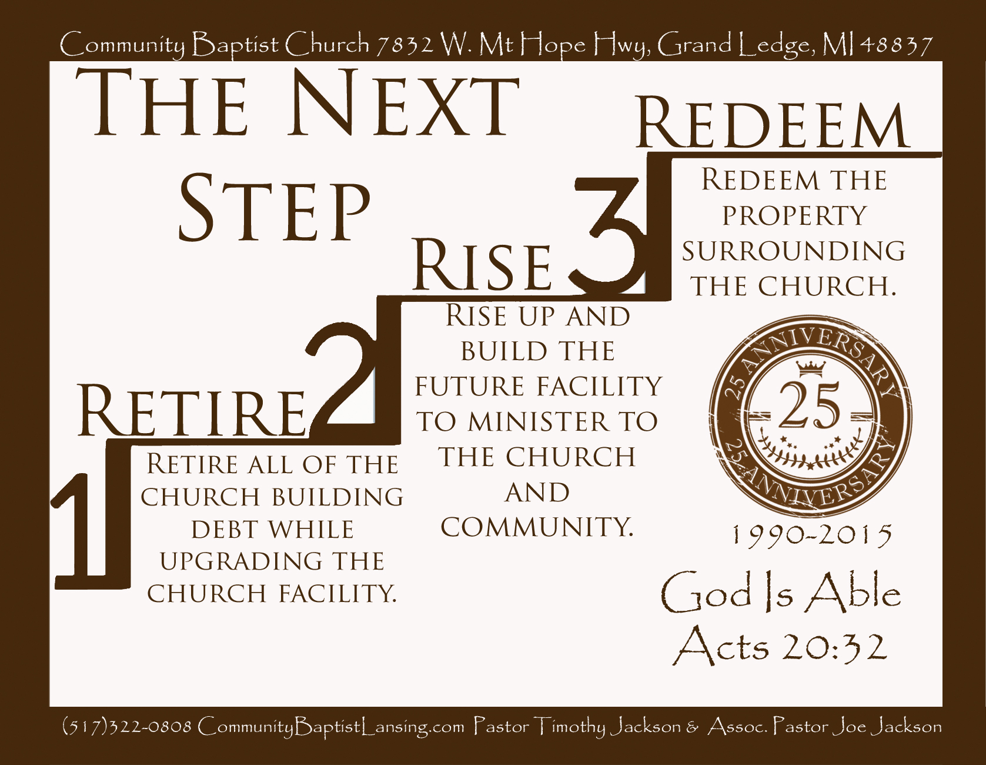
Community Baptist Church
7832 W. Mt Hope Hwy Grand Ledge, MI 48837 CommunityBaptistLansing.com (517)322-0808
Pastor Timothy Jackson
Assoc. Pastor Joe Jackson Please pray with us!
Next Step Sunday is March the 15th! For the next 29 days we are asking the whole church to join together, praying for our God to do something wonderful! We will be celebrating all that He has done for the last 25 years, and looking forward to all that He will keep doing for generations to come!
Will you join us in praying at least 5 minutes a day for the next 29 days!
Sunday | Monday | Tuesday | Wednesday | Thursday | Friday | Saturday
February 15 | February 16 | February 17 | February 18 | February 19 | February 20 | February 21
Start of 29 days of Prayer! | Don’t forget to pray five minutes today for Next Step Sunday… | Pray for Assoc. Pastor Joe it is his Birthday | Prayer Meeting at church tonight at 7PM! | Will you Pray for Our Missionaries today for 5 extra minutes? | Will you fast and pray for one meal today begging for the power of God? | Will you take an extra five minutes today to pray for our church?
February 22 | February 23 | February 24 | February 25 | February 26 | February 27 | February 28
See you in Sunday School at 9:45am and back at evening church at 6PM | Pray for Pastor as he prepares for Next Step Sunday! | And they said, Let us rise up and build.  Nehemiah 2:18 | Prayer meeting at church tonight at 7PM! | Pray without ceasing.  1 Thess. 5:17 | Almost half way there we can pray to see God do something Great! | God will provide if we trust his power! Ye have not because ye Ask not…..
March 1 | March 2 | March 3 | March 4 | March 5 | March 6 | March 7
Pastor will be sharing more of his vision for our church today at 6PM! | Will you pray for God to increase your ability to give to the Lord’s work today? | Please Join the rest of the church and pray for 30 Minutes today for us to see a miracle on the 15th | Prayer meeting at church tonight 7PM! | “The Only place that Power comes before Prayer is in a Dictionary” | The effectual fervent prayer of a righteous man availeth much. James 5:16 | Remember to change your clocks and our hearts to God’s time today!
March 8 | March 9 | March 10 | March 11 | March 12 | March 13 | March 14
Time Change Sunday Don’t Be Late for Sunday School at 9:45 | The Promises of God are new every morning! Pray for God to show his Power strong. | Can you fast from one thing today and spend that time in Prayer? | Special prayer meeting tonight at Church you are needed come pray with us at 7PM! | God Is Able!  Acts 20:32 | How about calling another member and praying with them on the phone today? | Buildings Don’t Change Lives but what happens in them does!
March 15
Next Step Sunday! Come Join us
The 15th of March, will be a Sunday to remember. After the 11AM service, we will have an Amazing meal just for you! Immediately followed by our Evening service at 1PM. During that service we will be challenged by our Pastor, to help our church reach more people for the cause of Christ! We will take up an offering to help us with the “Next Step” for our church’s Future. Step 1. Retire All of the church building debt, while upgrading the church facility. Step 2. Rise up and build the future facility to minister to the church and community. Step 3. Redeem the property surrounding the church

