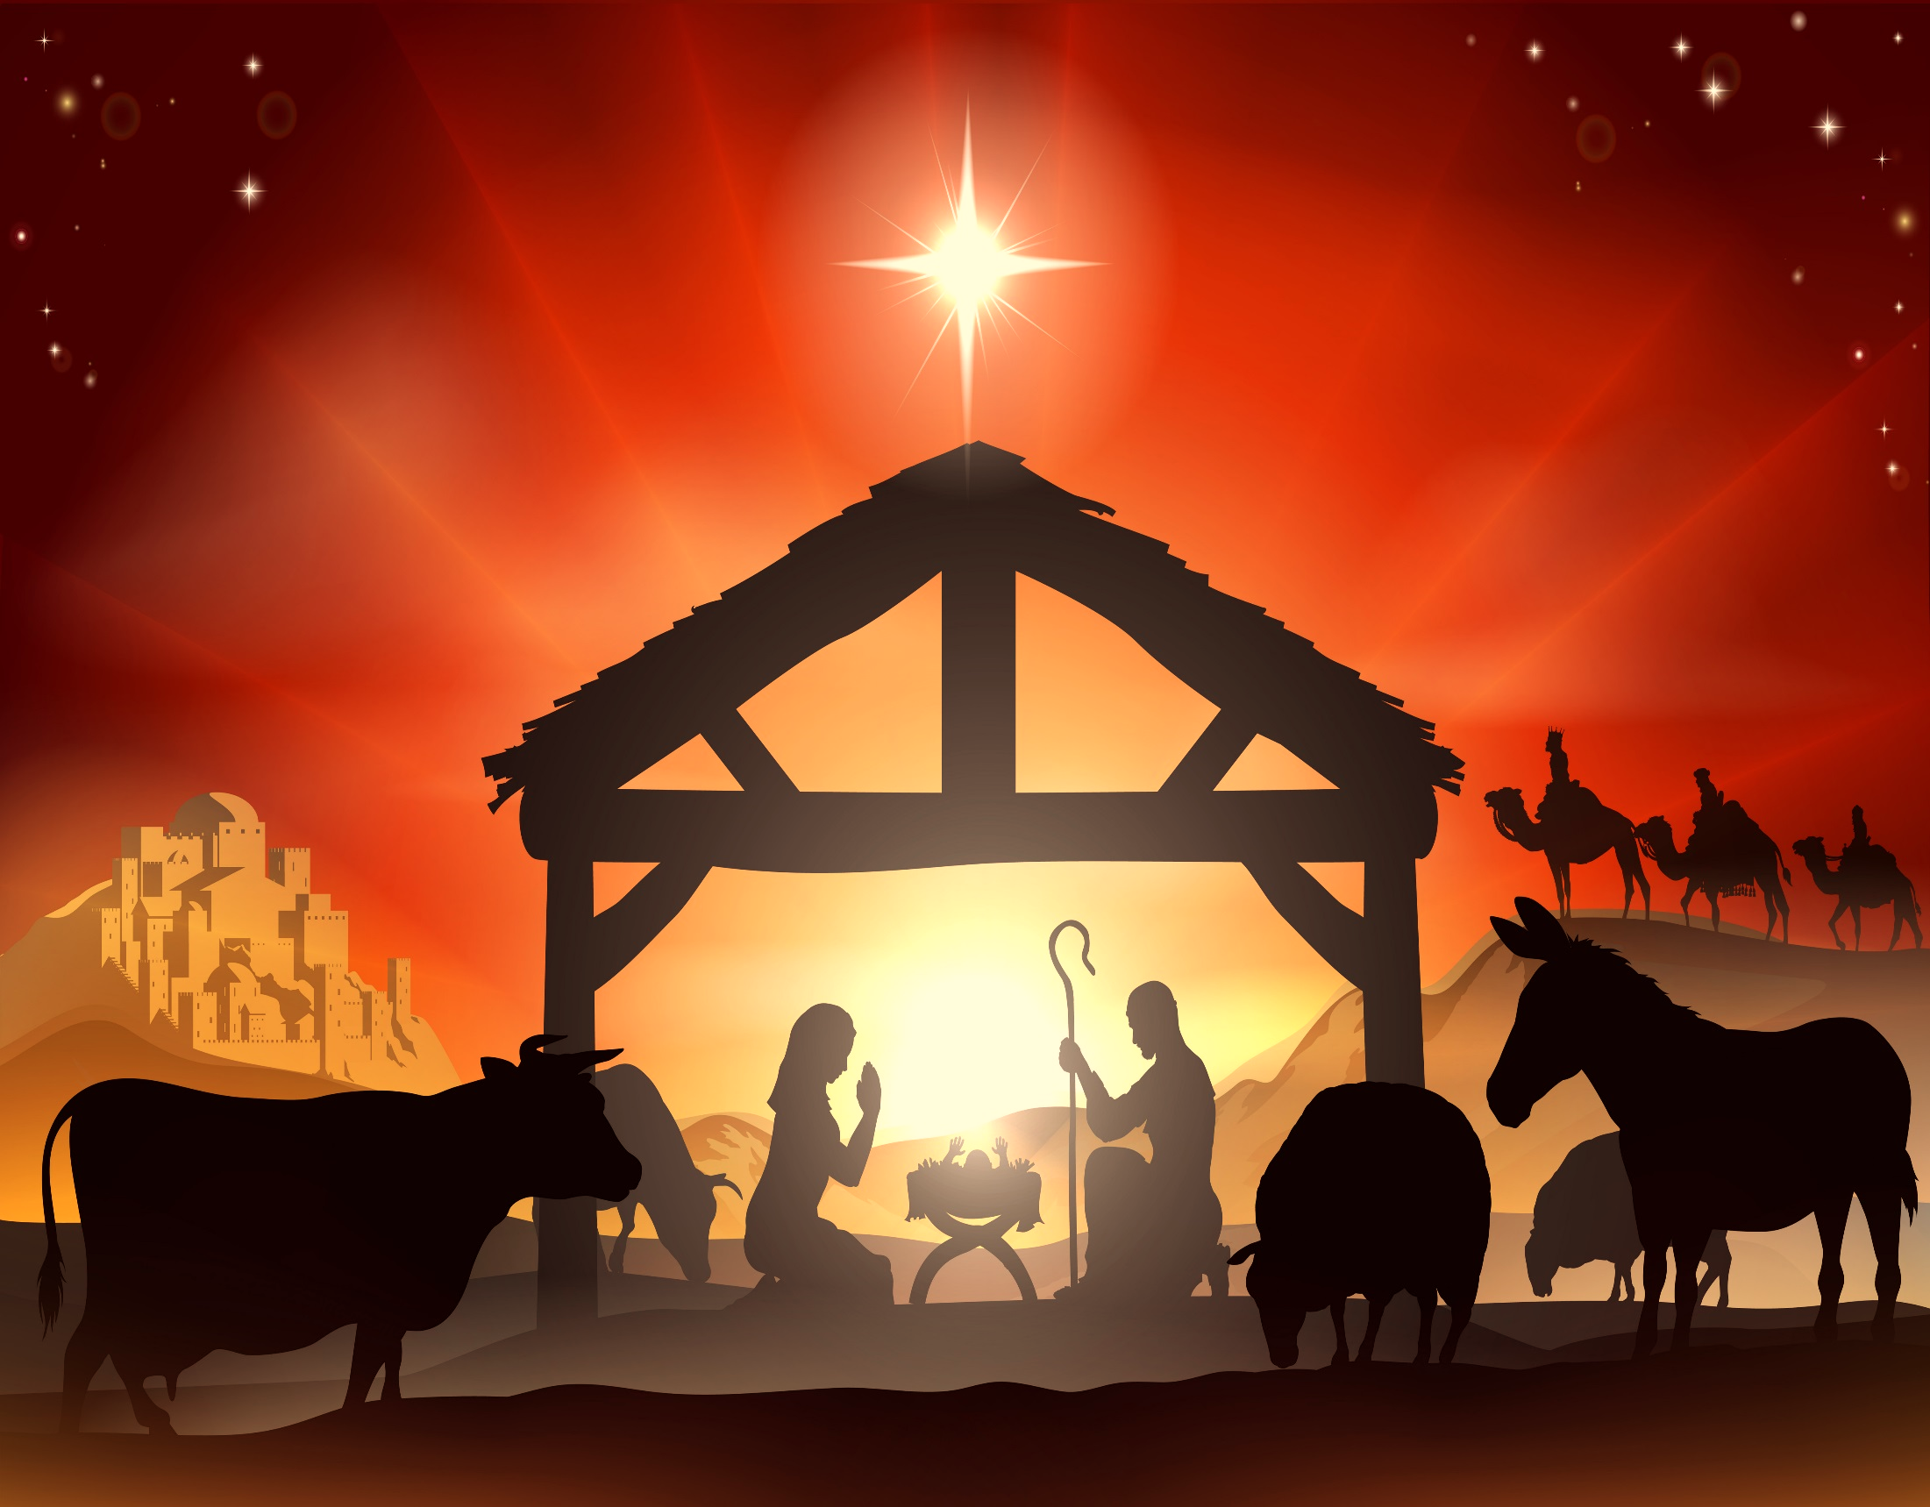
Community Baptist Church
2014 Christmas List for Jesus

Under $50
60- Bibles from the dollar store $1
40- Christmas Gifts $2-4.00 each
10- Young Boys Gifts
10- Teenage Boys Gifts
10- Young Girls Gifts
10- Teenage Girls Gifts
10- Gift cards for youth group to McDonalds and Pizza hut or fast food $5-$20 each
10- 25 Dollar Gas Cards for Transportation ministry.
100 AA Batteries $30
3 Rolls of first class forever stamps $47 Each
2 Wall mounted Sharps Container for Biohazard & Diabetic needles $20
5 Wall mounted Hand sanitizers $25 Each
5 Hand Sanitizer refills Packs $25 Each

Under $500
Missions Goal: Fifty Dollars for Each of our 8 Missionaries.
10,000 Community Week Flyers $400
10,000 Easter Flyers $200
5,000 Community Week Flyers or Easter Flyers delivered $250 Each
2 Brother Multi-Function Copier machine $180 Staples Each
Office furniture, Cabinets, storage solutions for Pastor Joe’s Office/ Classroom $500
5 Ceramic MH Lighting Systems for Parking Lot $80 Each
1 Wireless Hand held Microphones from Kingdom $499
1 Church attic Ladder $500 Lowes
10 A-Frame Picnic Tables $95 per Table Lowes
1 $500 Gift Card to Hobby Lobby for Church Decorations
1 Outdoor Trash Can $200
1 Outdoor Message Center for Pavilion $350
1 Shed remodel $500 Already Purchased!
25 New Hymnals for Choir Songs and Hymns from the Heart $500
18 Kids Chairs for Preschool Kids Room $380
18 Kids Chairs for 1-3 Grade Room $450

Under God’s Power
200 Chairs for Auditorium$10,000-$15,000
1 Pavilion electric-panel moved/outlets/lighting $875
1 Carpet vacuum for auditorium $575
1 Fridge for kitchen/Food Pantry $595
LED Exterior Wall Pack Lighting $3,000
1 2005 passenger Bus or Van $5000
1 Digital Piano $1500-$5000
New Pulpit and Platform seating $5000
LED Auditorium Lighting with Dimming $5,000
Bathrooms Refresh $5000
Parking Lot Sealed $5000
Parking Lot Resurfaced $50,000
Family Life Center $300,000-$500,000

Is there anything we missed that should be on the Christmas List for Jesus? ________________________________________________________________________________________________

Upcoming Events & “Christmas List For Jesus” Information

Dear Friend (s): I trust that you are having a terrific fall and that you are enjoying the Lord’s goodness. The colors of the changing leaves were brilliant this year and we give the Lord the glory for His creation! Wendy and I have experienced a busy season with the finishing of the Pavilion project, getting our home winterized and the church preparation for the Holidays. I really love it, don’t you? The pace is both refreshing and exciting anticipating what God has in store. He has done so much for us and the church in 2014, He is wonderful. This is a short letter of introduction of the coming events and also regarding the annual “Christmas List for Jesus” we publish for the church congregation.

Coming Events:
November 26 at 7 PM Prayer, Pie, Praise and Preaching Service at 7 PM
December 9 & 11 Church Directory Photos (scheduled at the church or on line through our web site)
December 14 at 9:45 Christmas List for Jesus gifts presented to the Lord and at 11 AM Patch Kids Christmas Pageant at 6 PM Christmas Musical
December 24 at 7 PM Christmas Eve Service
December 31 at 7 PM New Year’s Eve Service with preaching from the pew
January 4, 2015 at 6 PM Annual Vision Night Service

“Christmas List for Jesus”: Born out of requests by the congregation as to what is it the church needs to be more effective for Jesus in the next year, is the “Christmas List for Jesus”. Everyone has seen the classic Christmas list that a child has drafted for themselves but this list is all about others. What can we do this Christmas for the Lord? The “Christmas List for Jesus” is attached for you to prayer over, pick out one item and purchase (or you could just give a gift of money to pay for the item) before December 14 at 9:45 AM presentation. Whatever you want to do please mark it on the Master List attached to the bulletin board at church or contact me as to what you are going to do so we won’t duplicate your gift. Will you join my wife and me and participate this year in the Christmas List for Jesus? I hope you can. It will be wonderful to see the Lord receive His glory. “Glory to God in the highest…”Lk. 2:14

Thank you for all you do for the Lord,
Pastor Jackson

