29 Days of Prayer
For Celebration Sunday
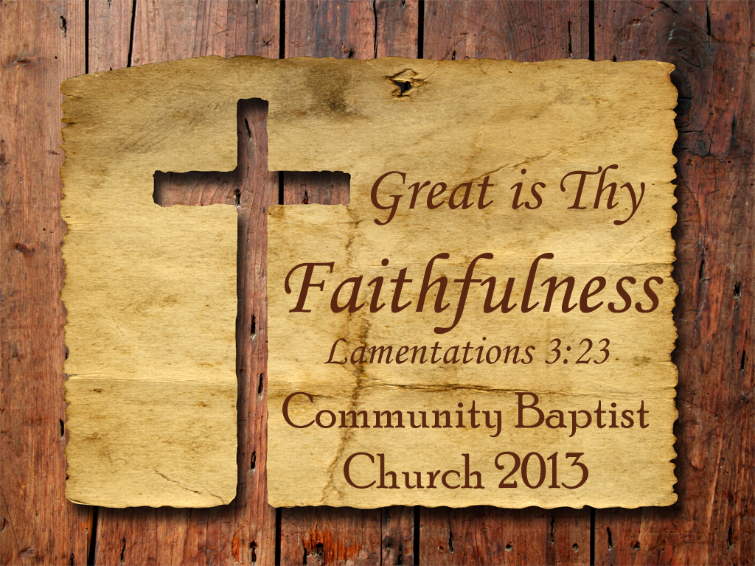
Community Baptist Church
7832 W. Mt Hope Hwy Grand Ledge, MI 48837 CommunityBaptistLansing.com (517)322-0808
Pastor Timothy Jackson
Asst. Pastor Joe Jackson Please pray with us!
Celebration Sunday is March the 17th! For the next 29 Days we are asking the whole church to join together, praying for our God to do something wonderful! We will be celebrating all that He has done for the last 23 years and looking forward to all that He will keep doing for generations to come!
Will you join us in praying at least 5 minutes a day for the next 29 days!
Sunday | Monday | Tuesday | Wednesday | Thursday | Friday | Saturday
February 17 | February 18 | February 19 | February 20 | February 21 | February 22 | February 23
Start of 29 days of Prayer! | Don’t forget to pray five minutes today for Celebration Sunday… | Ye have not because ye Ask not….. | Prayer Meeting at church tonight at 7PM! | Great is thy Faithfulness Lam3:23 | “The Only place that Power comes before Prayer is in a Dictionary” | Will you take an extra five minutes today to pray for our church?
February 24 | February 25 | February 26 | February 27 | February 28 | March 1 | March 2
See you in Sunday School at 9:45am and back at evening church at 6PM | The effectual fervent prayer of a righteous man availeth much. James 5:16 | How about calling another member and praying with them on the phone today? | Prayer meeting at church tonight at 7PM! | The Promises of God are new every morning! | Almost half way there we can pray to see God do something Great! | Ladies night out Shopping Fanatics unite! 12-3PM at Lansing Mall.
March 3 | March 4 | March 5 | March 6 | March 7 | March 8 | March 9
Pastor will be sharing more of his vision for our church today at 6PM! | Will you fast and pray for one meal today begging for the power of God? | Please Join the rest of the church and pray for 30 Minutes today for us to see a miracle on the 17th | Prayer meeting at church tonight 7PM! | Pray without ceasing. 1 Thessalonians 5:17 | Will you pray for God to increase your ability to give to the Lord’s work today? | Remember to change your clocks and our hearts to God’s time today!
March 10 | March 11 | March 12 | March 13 | March 14 | March 15 | March 16
Time Change Sunday Don’t Be Late for Sunday School at 9:45 | Pray for Pastor as he prepares for Celebration Sunday! | Can you fast from one thing today and spend that time in Prayer? | Special prayer meeting tonight at Church you are needed come pray with us at 7PM! | And they said, Let us rise up and build.  Nehemiah 2:18 | Will you pray today? One prayer can move a mountain! | Buildings Don’t Change Lives but what happens in them does!
March 17
Celebration Sunday! Come Join us
On the 17th of March, after the morning service, we will be having a delicious meal thanking you, for your faithfulness to God. We will be challenged by our Pastor to help our church reach more people for the cause of Christ! We will take up an offering to Retire our Church’s loan on our Building and to help us as we plan to rise up and Build for the future, to reach out and help our world for Jesus.

